**THE PEARL EXAMINATION 2024**

**TERM II QUALITY ASSURANCE**

**BABY CLASS: (3 – 4 YEARS)**

**LEARNING AREA 3: HEALTH HABITS**

**My name is: …………………………….…………..………………………….**

**My School is: ………………………….………..………….…………………..**

**I am in: ………………………………..……………………………………………………..**

1. 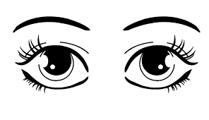**Match the same body parts.**

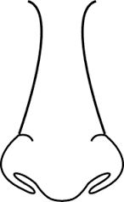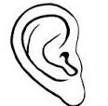

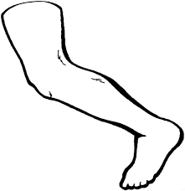







1. **Trace.**

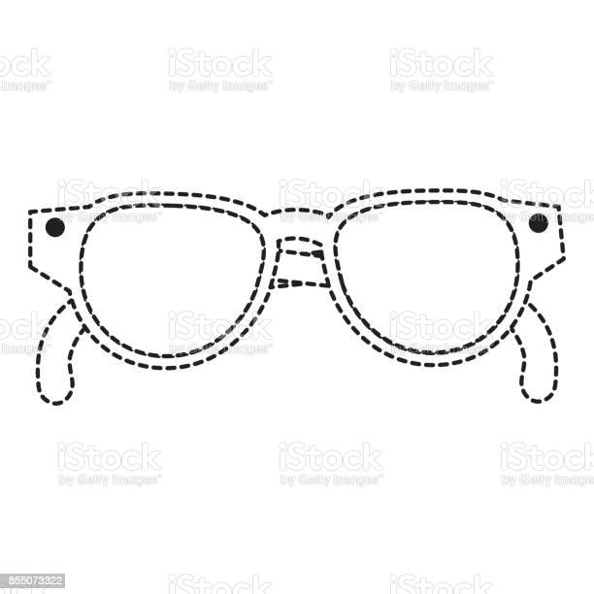

1. **Tell these things that can harm the eyes.**

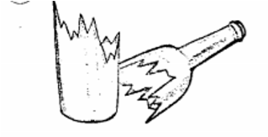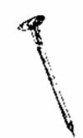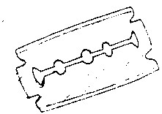

1. 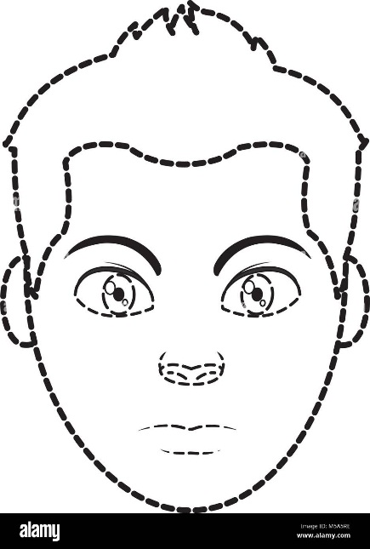**Join the dots.**
2. **Colour the yellow banana.**

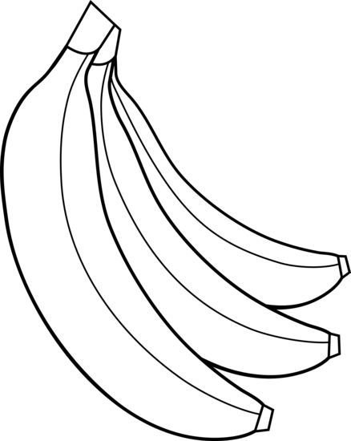

**END**